Assignment 10
Members: Edgar Castellanos, Brian Batinchok, Jesse Lambert, Alex Lorenzo, Ryon Riley, Ian Vigrass
- R1(config)# ipv6 unicast-routing
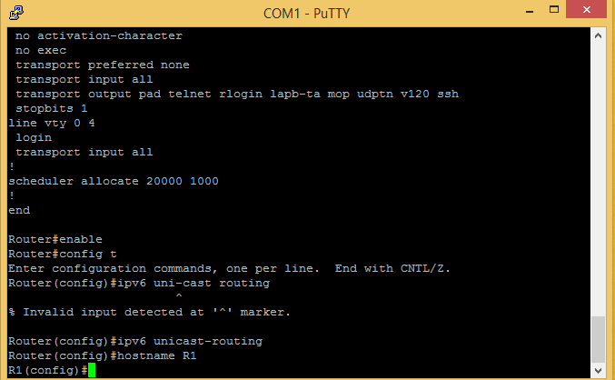

- R2(config)# ipv6 unicast-routing

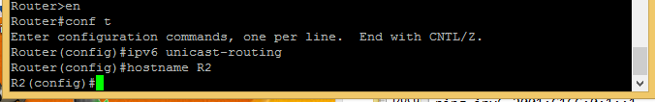

- R1 int s0/0/0 configuration
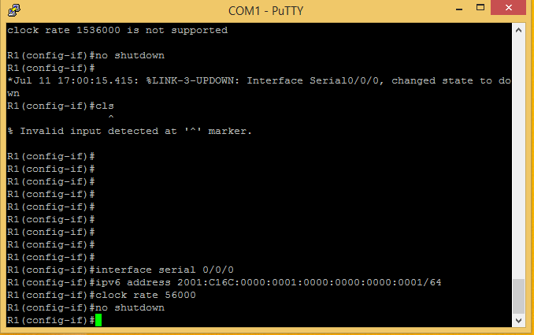

- R2 int s0/0/1 configuration
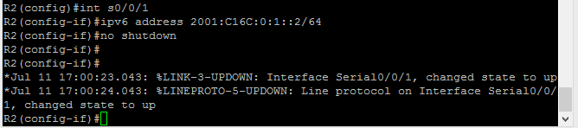

- Show ipv6 interface
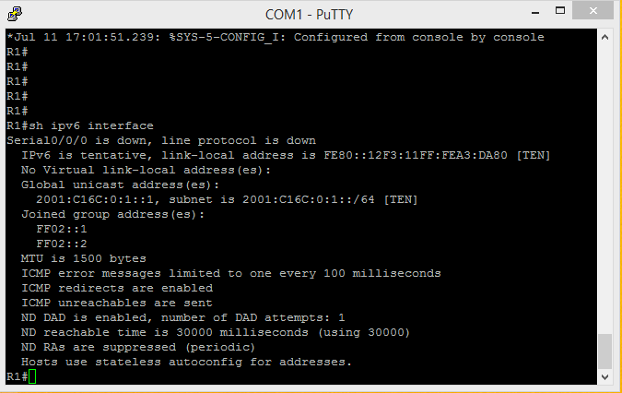

- Show running-config R1
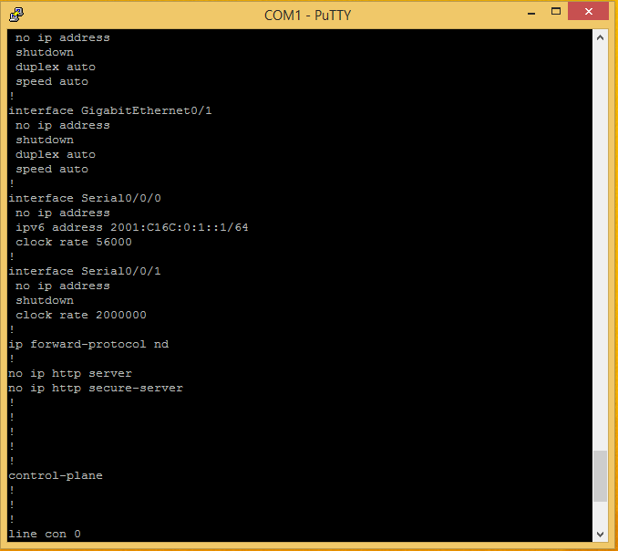

- R1 sh ipv6 interface brief
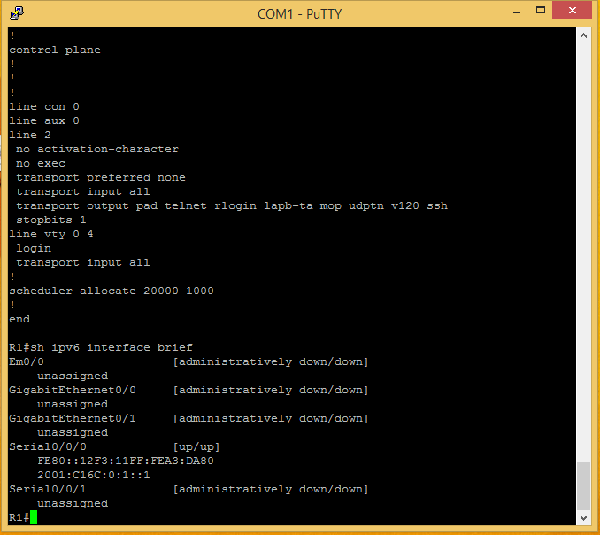

- R2 show ipv6 route

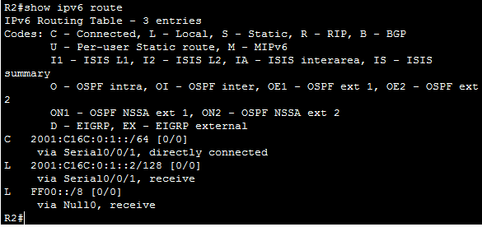

- R2# ping ipv6 2001:C16C:0:1::1
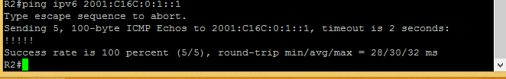

- Hostname R1-WAN s0/0/0 and hostname R2 R2-WAN s0/0/1
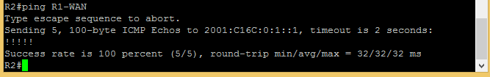

- R1 g0/1 IPv6 address abbreviation
2001:C16C:0:2::/64

- R1 eui-64 configuration
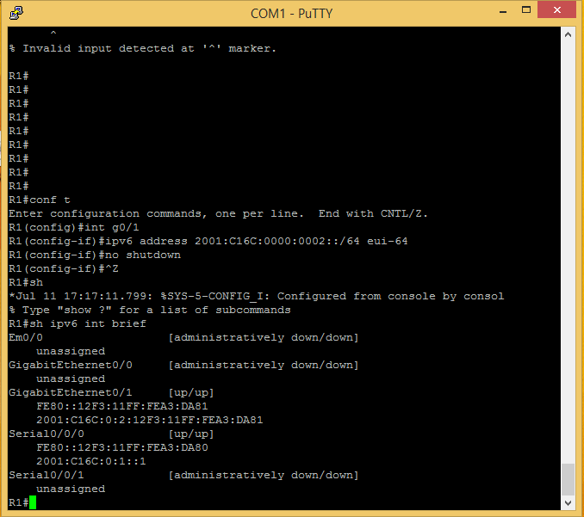
- R2 eui-64 configuration
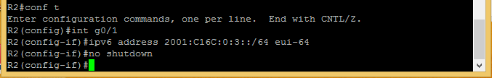

- R2# sh ipv6 interface brief
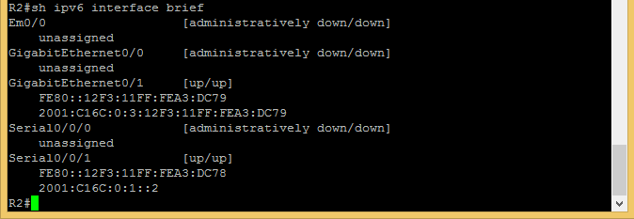

- R2# sh ipv6 route
